2️⃣1️⃣ HTML + JAVASCRIPT

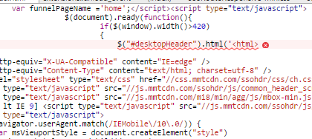
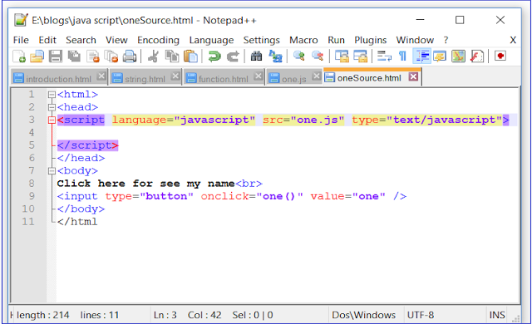
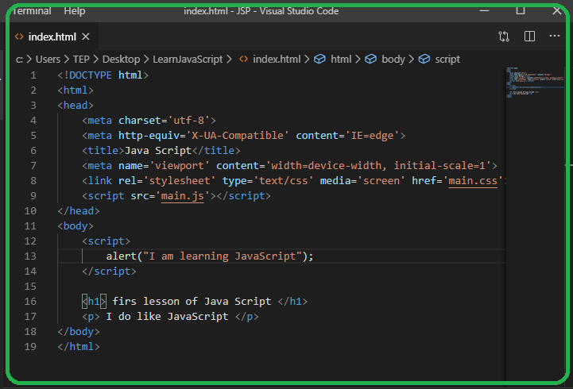
HTML + JavaScript is used to add behavior and interactivity.
📌 HTML = structure
📌 JavaScript = logic & action

🔹 <script> Tag
Used to write or connect JavaScript.
<script>
alert("Hello World");
</script>

🔹 Inline JavaScript
JS written inside HTML tag.
<button onclick="alert('Clicked')">Click</button>
✔ Easy
❌ Not recommended for large apps

🔹 External JavaScript (BEST PRACTICE ✅)
<script src="app.js"></script>
✔ Clean code
✔ Reusable
✔ Industry standard
📌 Place JS before </body> or use defer.

🔹 DOM Access Basics
DOM = Document Object Model
<script>
document.getElementById("title").innerText = "Hello";
</script>
📌 JS can:
✔ Read HTML
✔ Modify HTML
✔ Respond to events

2️⃣2️⃣ HTML ENTITIES & SYMBOLS

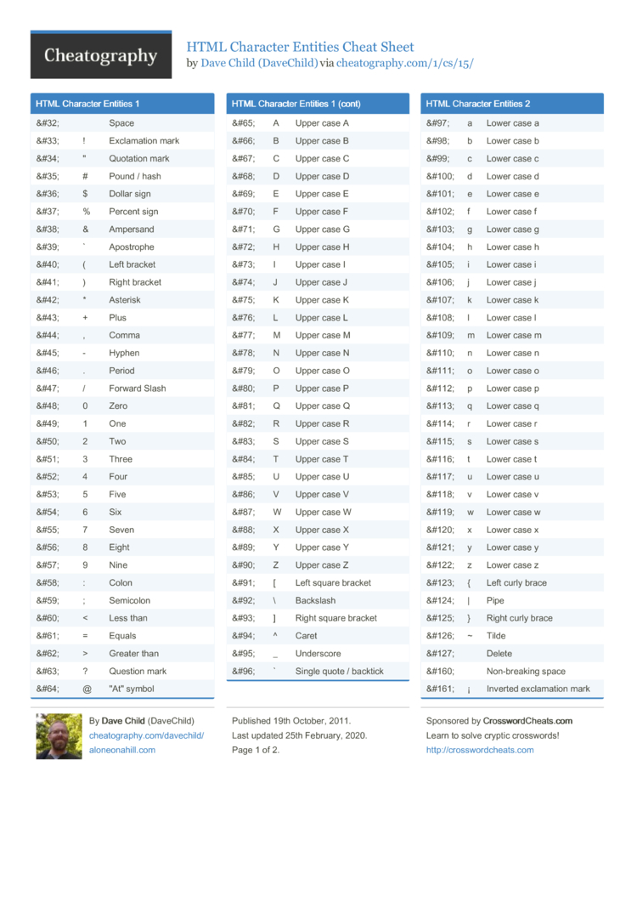
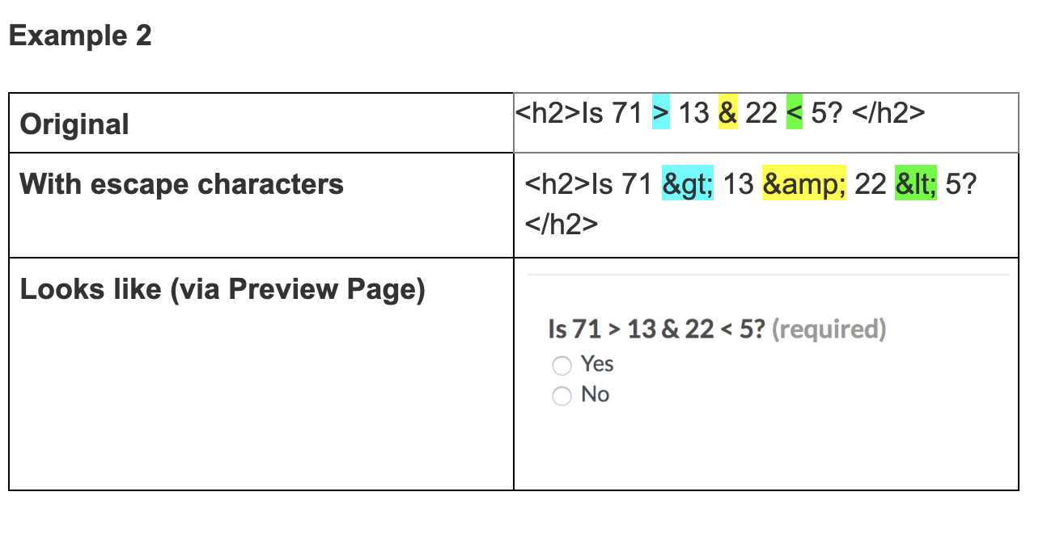
Entities are used to display reserved or special characters.

🔹 Common HTML Entities
Symbol | Entity
Space | &nbsp;
< | &lt;
> | &gt;
© | &copy;
® | &reg;
<p>5 &lt; 10</p>
📌 Prevents browser confusion.

2️⃣3️⃣ HTML EMOJIS 😀
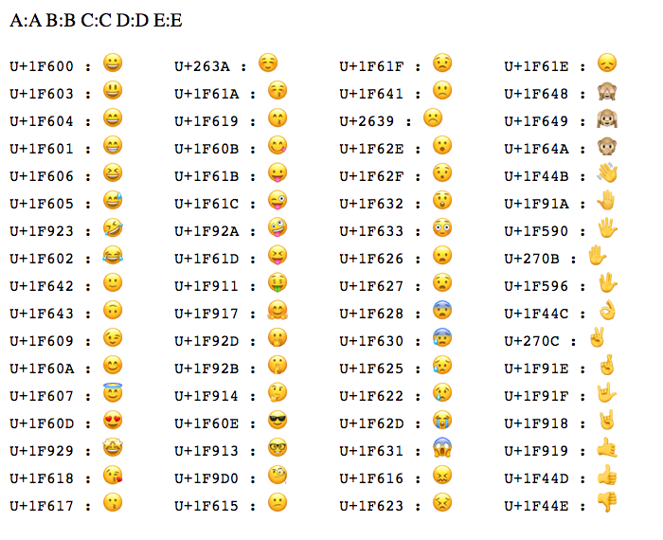
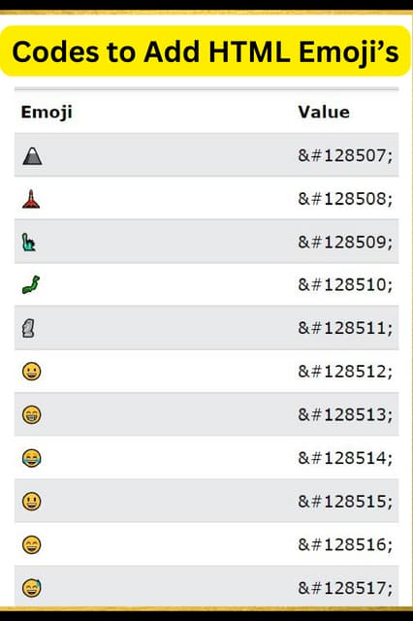
HTML supports emojis using UTF-8 encoding.
<p>Happy 😀</p>
✔ Works in all modern browsers
✔ Requires UTF-8 charset
📌 Emojis improve user engagement.

2️⃣4️⃣ HTML CHARSET & ENCODING

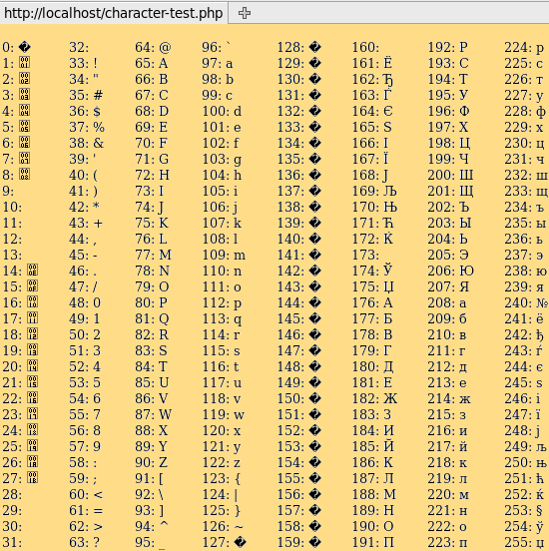
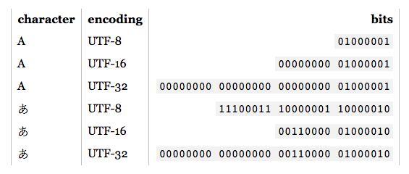
Charset defines how characters are stored and displayed.

🔹 UTF-8 (STANDARD 🔥)
<meta charset="UTF-8">
✔ Supports all languages
✔ Supports emojis
✔ Prevents text corruption
📌 Without UTF-8 → symbols break ❌

2️⃣5️⃣ HTML FILE PATHS
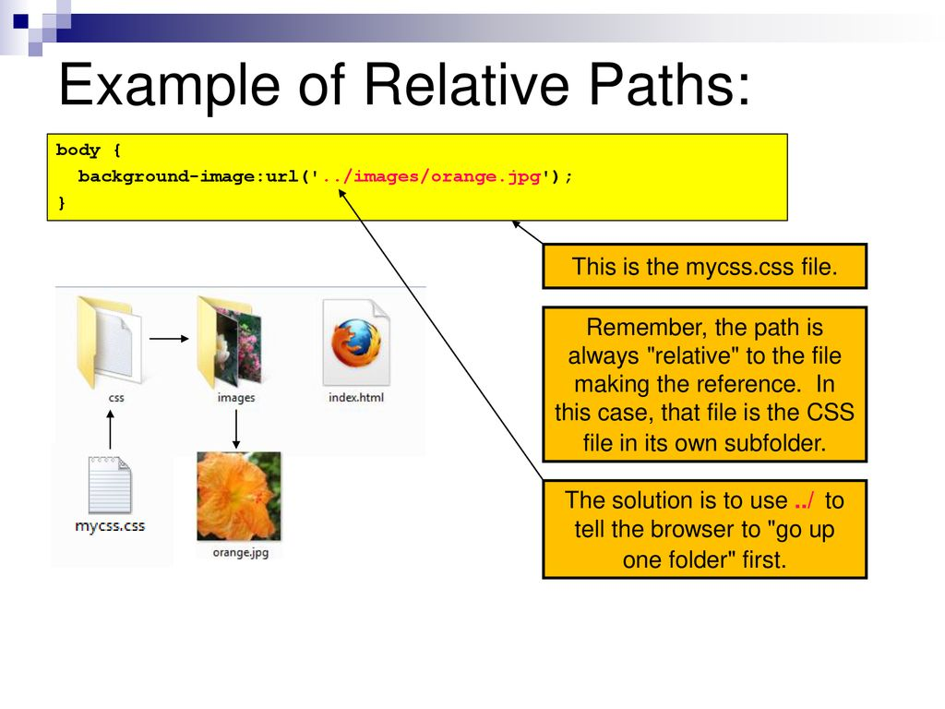
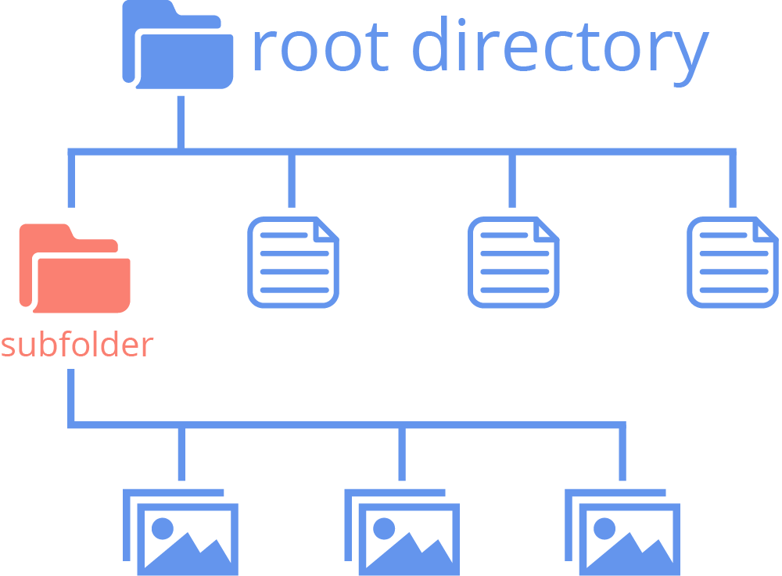
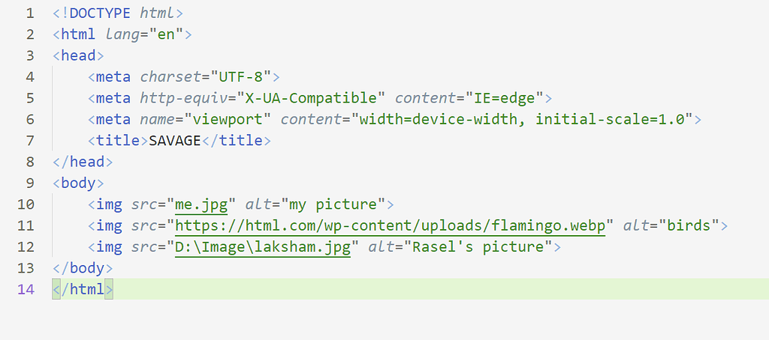
File paths tell the browser where files are located.

🔹 Absolute Path
<img src="https://example.com/images/photo.jpg">
✔ Full URL
❌ Depends on internet

🔹 Relative Path (PREFERRED ✅)
<img src="images/photo.jpg">
✔ Works offline
✔ Best for projects
📌 Relative paths depend on current file location.

